NAME: AKSHAYA S ; REG.NO: 22TD0005 ; YEAR/SEM/SEC: Y2/S4/B

BINARY SEARCH

#include<iostream>
using namespace std;
int main()
{
int a[30],x,k,l,m,n,h;
cout<<"Enter the values of n";
cin>>n;
cout<<"Enter the elements";
for(k=0;k<n;k++)
cin>>a[k];
cout<<"Enter the element to search";
cin>>x;
l=0;
h=n-l;
while(l<=h)
{
m=(l+h)/2;
if(x==a[m])
{
cout<<"\nSuccessful search\n";
cout<<"\nThe element is present"<<m+1;
cout<<"\nThe element is:"<<x;
break;
}
if(x<a[m])
{
h=m-1;
continue;
}
if(x>a[m])
{
l=m+1;
continue;
}
}
while(l>=h)
{
cout<<"Unsuccessful search";
}
return 0;
}

OUTPUT:

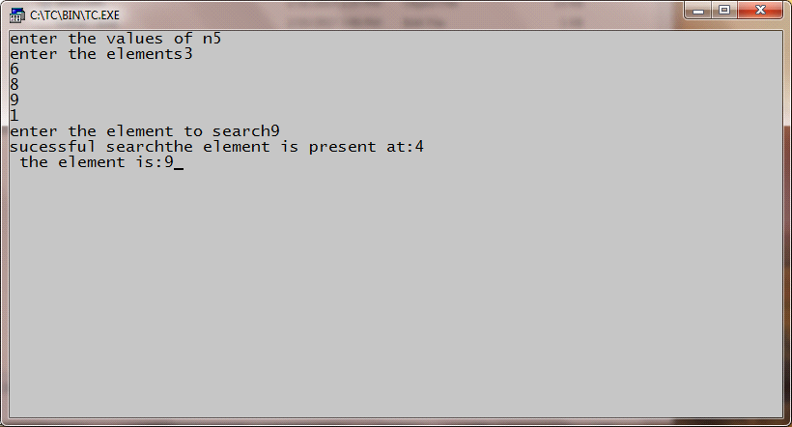

NAME: AKSHAYA S ; REG.NO: 22TD0005 ; YEAR/SEM/SEC: Y2/S4/B

MERGE SORT

#include<iostream>
using namespace std;
void merge (int[],int,int,int);
void part(int[],int,int);
int main()
{
int arr[30];
int i, size;
cout<<"\n\t-----merge sorting method-----\n\n";
cout<<"\nEnter total no of elements:";
cin>>size;
for(i=0;i<size;i++)
{
cout<<"\nEnter"<<i+1<<"element:";
cin>>arr[i];
}
part (arr,0,size-1);
cout<<"\n\n----merge sorted elements-----\n\n";
for(i=0;i<size;i++)
cout<<"\n"<<arr[i];
return 0;
}
void part(int arr[],int min,int max)
{
int mid;
if(min<max)
{

mid=(min+max)/2;
part(arr,min,mid);
part(arr,mid+1,max);
merge(arr,min,mid,max);

}
}
void merge(int arr[],int min,int mid, int max)
{
int temp[30];
int i,j,k,m;
j=min;
m=mid+1;
for(i=min;j<=mid&&m<=max;i++)
{
if(arr[j]<=arr[m])
{
temp[i]=arr[j];
j++;
}
else
{
temp[i]=arr[m];
m++;
}
}
if(j>mid)
{
for(k=m;k<=max;k++)
{
temp[i]=arr[k];
i++;
}
}
else
{
for(k=j;k<=mid;k++)
{
temp[i]=arr[k];
i++;
}
}
for(k=min;k<=max;k++)
arr[k]=temp[k];
}

OUTPUT:

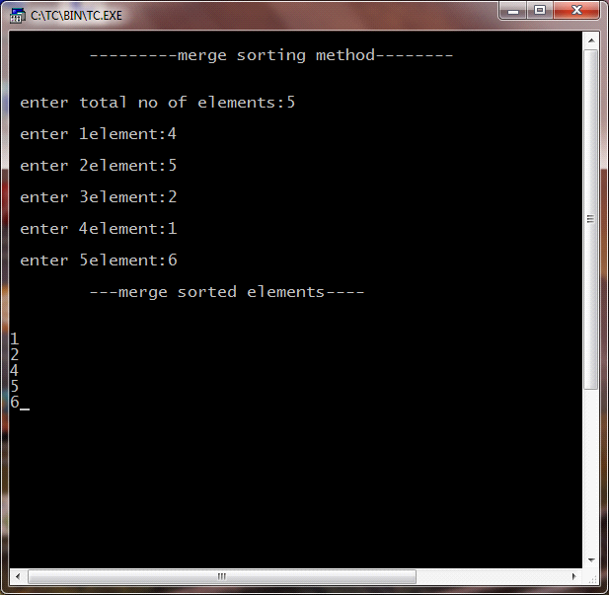

NAME: AKSHAYA S ; REG.NO: 22TD0005 ; YEAR/SEM/SEC: Y2/S4/B

QUICK SORT

#include<iostream>
using namespace std;
void quick(int a[], int,int);
void split (int a[],int,int);
int main()
{
int i,n,a[20];
cout<<"\nEnter the limit:";
cin>>n;
cout<<"\nEnter the elements to be sorted";
for(i=0;i<n;i++)
{
cout<<"\n\t a["<<i<<"]";
cin>>a[i];
}
quick(a,0,n-1);
cout <<"\nThe sorted elements are:";
for(i=0;i<n;i++)
cout<<"\n"<<a[i];
}
void quick(int a[],int first, int last)
{
int x,i,j;
if(first<last)
{
x=a[first];
i=first;
j=last;
while(i<j)
{
while(a[i]<=x&&i<last)
i++;
while(a[j]=x&&j>first)
j--;
if(i<j)
split(a,i,j);
}
split (a,first,j);
quick(a,first,j-1);
quick(a,j+1,last);
}
}
void split(int a[],int i,int j)
{

int temp;
temp=a[i];
a[i]=a[j];
a[j]=temp;
}

OUTPUT:

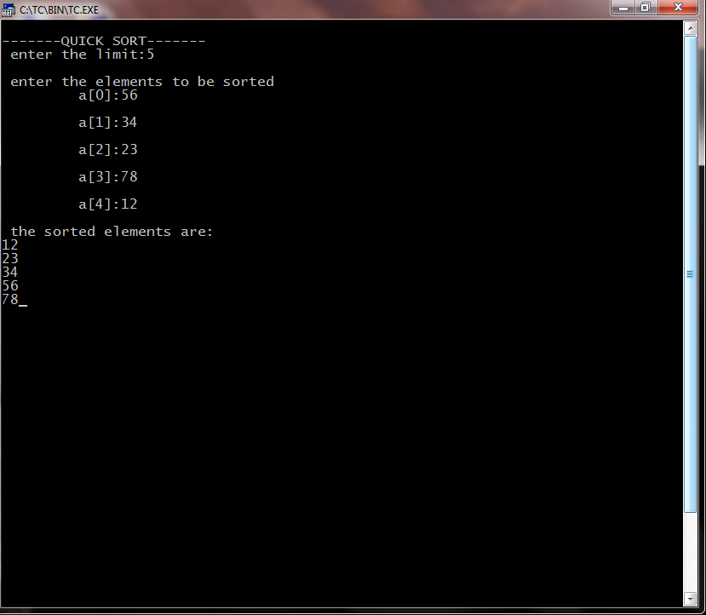

NAME: AKSHAYA S ; REG.NO: 22TD0005 ; YEAR/SEM/SEC: Y2/S4/B

KNAP SACK

#include<iostream>
using namespace std;
float w[100],v[100],x[100],wt,wgt[100];
class greed
{
private:
int i,j,n;
float r[100],f,total,t,rat,pro,wei,op,opti;
public:
void getdata();
void ratio();
void profit();
void weight();
void optimal();
};
void greedy(int n)
{
int wgt,i;
for(i=0;i<n;i++)
x[i]=0;
wgt=i=0;
while(wgt<wt)
{

if(wgt+w[i]<=wt)
{
x[i]=1;
wgt+=w[i];
}
else
{
x[i]=(wt-wgt)/w[i];
wgt+=(x[i]*w[i]);
}
i++;
}
}
void greed::getdata()
{
cout<<"\nEnter no of objects ______";
cin>>n;
cout<<"\nEnter the capacity of the bag ____";
cin>>wt;
for(i=0;i<n;i++)
{
cout<<"weight=";
cin>>w[i];
cout<<"profit=";
cin>>v[i];
r[i]=v[i]/w[i];

}

}
void greed::ratio()
{

cout<<"GREEDY BY RATIO2
2222\n";
for(i=0;i<n;i++)
for(j=i+1;j<n;j++)
if(r[i]<r[j])
{
t=w[i];w[i]=w[j];w[j]=t;
t=v[i];v[i]=v[j];v[j]=t;
t=r[i];r[i]=r[j];r[j]=t;

}
greedy(n);
for(i=0;i<n;i++)
{
cout<<"\n weight="<<w[i];
cout<<"\n profit="<<v[i];
cout<<"\n ratio="<<r[i];
cout<<"\n fraction+"<<x[i];
total+=(x[i]*v[i]);
}
cout<<"\n feasible profit="<<total;
rat=total;
total=0;
}
void greed::profit()
{
cout<<"\n GREEDY BY PROFIT";
for(i=0;i<n;i++)
for(j=i+1;j<n;j++)
if(v[i]<v[j])
{
t=w[i];w[i]=w[j];w[j]=t;
t=v[i];v[i]=v[j];v[j]=t;
t=r[i];r[i]=r[j];r[j]=t;
}
greedy(n);
for(i=0;i<n;i++)
{
cout<<"\n weight="<<w[i];
cout<<"\n profit="<<v[i];
cout<<"\n ratio="<<r[i];
cout<<"\n fraction="<<x[i];
total+=(x[i]*v[i]);
}
cout<<"\n feasible profit="<<total;
pro=total;
total=0;
}
void greed::weight()
{
cout<<"GREEDY BY WEIGHT";
for(i=0;i<n;i++)
for(j=j+1;j<n;j++)
if(w[i]<w[j])
{
t=w[i];w[i]=w[j];w[j]=t;
t=v[i];v[i]=v[j];v[j]=t;
t=r[i];r[i]=r[j];r[j]=t;
}
greedy(n);
for(i=0;i<n;i++)
{
cout<<"\n weight="<<w[i];
cout<<"\n profit="<<v[i];
cout<<"\n ratio="<<r[i];
cout<<"\n fraction="<<x[i];
total+=(x[i]*v[i]);
}
cout<<"\n feasible profit="<<total;
wei=total;
}
void greed::optimal()
{
if(rat>pro)
op=rat;
else
op=pro;
if(op>wei)
opti=op;
else
opti=wei;
cout<<"\n optimal solutions........"<<opti;
}
int main()
{
greed s;
cout<<"\nKNAPSACK PROBLEM";
s.getdata();
s.ratio();
s.profit();
s.weight();
s.optimal();

}

OUTPUT:

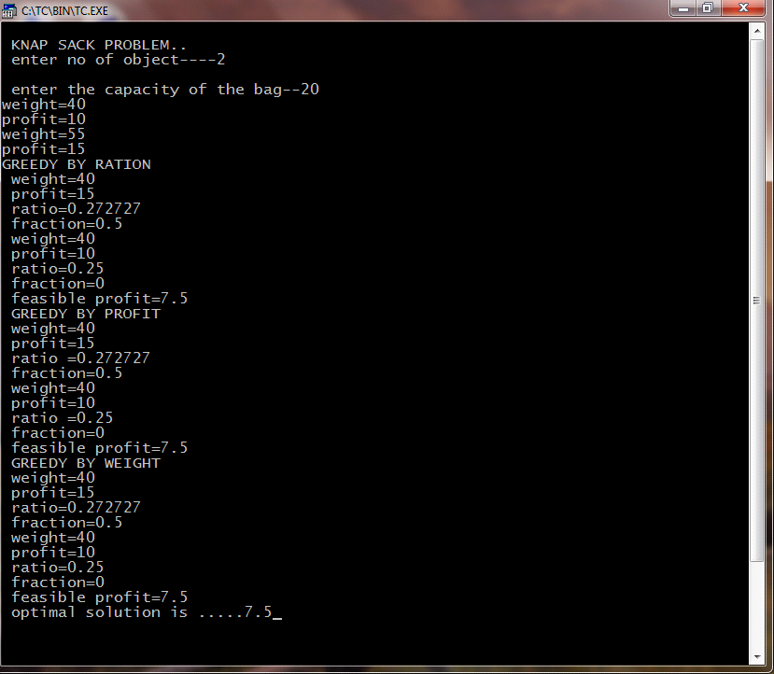

NAME: AKSHAYA S ; REG.NO: 22TD0005 ; YEAR/SEM/SEC: Y2/S4/B

SINGLE SOURCE SHORTEST PATH

#include<iostream>
using namespace std;
class path
{
private:
int i,j,m,n,b[50],cost[20][20],k,d[50];
int u,v,w,num,s[20];
public:
void getdata();
void sp();
void display();
};
void path::getdata()
{
cout<<"\n***SINGLE SOURCE SHORTEST PATH***\n";
cout<<"\n enter the number of nodes:";
cin>>n;
cout<<"\n enter the cost\n";
for(i=1;i<=n;i++)
{
for(j=1;j<=n;j++)
{
if(i==j)
{
cost[i][j]=0;
}
else
{
cout<<"\n cost["<<i<<","<<j<<"]:";
cin>>cost[i][j];
}
}
cout<<"\n";
}
}
void path::sp()
{
k=1;
cout<<"\n the cost of vertices are:\n";
cout<<"\t";
for(i=1;i<=n;i++)
cout<<i<<"\t";
for(i=1;j<=n;i++)
cout<<"--------";
cout<<"\n";
for(i=1;i<=n;i++)
{
cout<<i<<"\t";
for(j=1;j<n;j++)
{
cout<<cost[i][j]<<"\t";
}
cout<<"\n";
}
cout<<"\n enter the source vertex:";
cin>>v;
for(i=1;i<=n;i++)
{
s[i]=0;
d[i]=cost [v][i];
}
s[v]=1;
b[k++]=v;
d[v]=0;
for(num=2;num<=n;num++)
{
m=9999;
for(j=1;j<=n;j++)
if((m>d[j])&&(s[j]==0))
{
m=d[j];
u=j;
}
s[u]=1;
b[k+1]=u;
for(w=1;w<=n;w++)
{
if(d[w]>(d[u]+cost[u][w])&&(s[w]==0))
{
d[w]=(d[u]+cost[u][w]);
}
}
cout<<"\n";
}
}
void path::display()
{
cout<<"\n";
cout<<"\n the shortest path with source vertex"<<v<<"is\n";
cout<<"\n\t\t"<<b[i];
for(i=2;i<k;i++)
cout<<"----->"<<b[i];
}
int main()
{
path p;
p.getdata();
p.sp();
p.display();
}

OUTPUT :

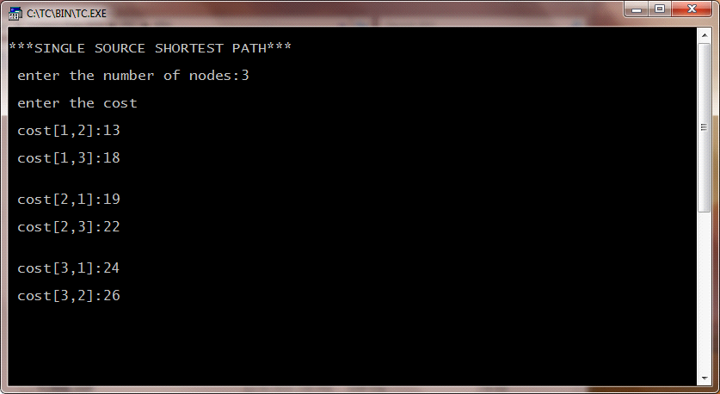
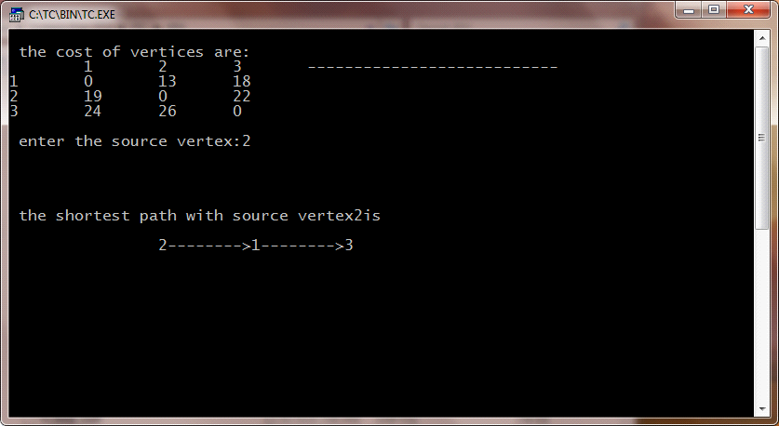

NAME: AKSHAYA S ; REG.NO: 22TD0005 ; YEAR/SEM/SEC: Y2/S4/B

MULTISTAGE GRAPH

#include<iostream>
using namespace std;
struct fwd
{

int l;
int a[20];
};
struct fwd s1[10];
int main()
{
int k,i,j,n,p[10],m,z,cost[50],v,c[20][20];
cout<<"Enter the number of stages"<<i<<":";
cin>>k;
n=0;
for(i=1;i<=k;i++)
{
cout<<"no of vertices of the stage"<<i<<"i";
cin>>s1[i].l;
n+=s1[i].l;
for(j=1;j<=s1[i].l;j++)
{
cout<<"Enter the value of vertex"<<j<<":";
cin>>s1[i].a[j];
}
}
for(i=1;i<k;i++)
{
for(j=s1[i].a[1];j<=s1[i].a[s1[i].l];j++)
{
for(z=s1[i+1].a[1];z<=s1[i+1].a[s1[i+1].l];z++)
{
cout<<"\n enter the cost of c ["<<j<<"]["<<z<<"]";
cin>>c[j][z];
}
}
}
cost [n]=0;
int min,d[50],t;
for(i<=k-1;i>=1;i--)
{
for(j=s1[i].a[i];j<=s1[i].a[s1[i].l];j++)
{
min=999;
for(z=s1[i+1].a[1];z<=s1[i+1].a[s1[i].l];z++)
{
if(cost[z]+c[j][z<min])
min=cost[z]+c[j][z];
t=z;
}
cost[j]=min;
d[j]=t;
}
}
p[1]=1;
p[k]=n;
for(i=2;i<k;i++)
{
p[i]=d[p[i-1]];
}
for(i=1;i<k;i++)
{
cout<<p[i]<<".....";
}
cout<<p[k];
return 0;
}

OUTPUT:

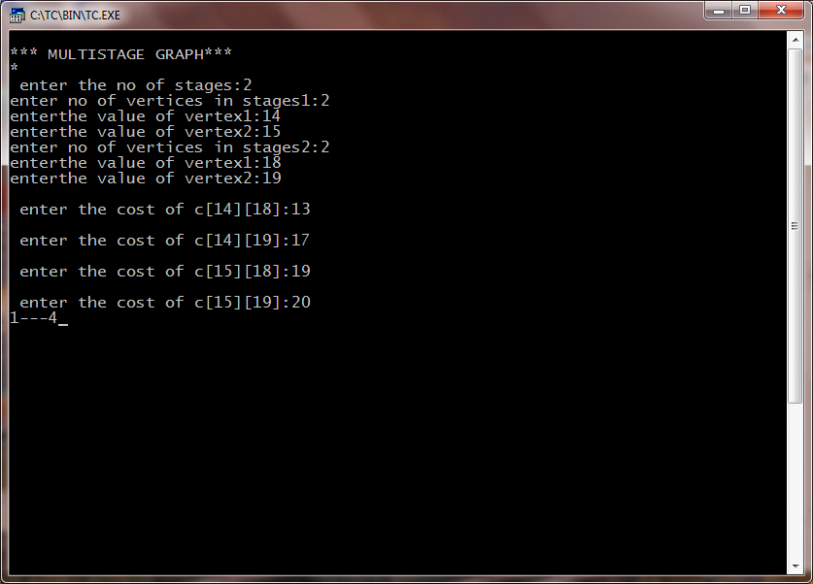

NAME: AKSHAYA S ; REG.NO: 22TD0005 ; YEAR/SEM/SEC: Y2/S4/B

0/1 KNAP SACK PROBLEM

#include<iostream>
using namespace std;
int c,z[20],t[50][50],s[20],i,j,pt[20],wt[20],x[20],m,n,w;
class knp
{
public:
void get();
void table();
void select();
void display();
}
k;
void knp::get()
{
cout<<"\n\t\0\1 KNAPSACK PROBLEM....";
cout<<"\nENTER THE CAPACITY OF THE BAG...";
cin>>m;
cout<<"\n enter the no of objects...";
cin>>n;
for(i=1;i<=n;i++)
{
cout<<"\nEnter the weight of objects...";
cin>>wt[i];
cout<<"\nEnter the profit of object"<<i<<"....";
cin>>pt[i];
}
}
void knp::table()
{
for(i=1;i<=n;i++)
{
for(j=0;j<=m;j++)
{
if((i==1)&&(j<wt[i]))
t[i][j]=0;
if((i==1)&&(j>=wt[i]))
t[i][j]=pt[i];
if((i>1)&&(j<wt[i]))
t[i][j]=t[i-1][j];
if((i>1)&&(j>=wt[i]))
t[i][j]=pt[i]+t[i-1][j-wt[i]];
}
}
cout<<"\n\t\t table\n";
for(i=1;i<=n;i++)
{
for(j=0;j<=m;j++)
cout<<t[i][j]<<"\t";
cout<<"\n";
}
}
void knp::select()
{
int q=0;
c=0;
int a,b,d;
i=n;
for(j=m;j>=0;j--)
{
if(t[i][j]==t[i-1][j])
{
a=i-1;
if(t[a][j]==t[a-1][j-wt[a]]+pt[a])
{

}
else
{
z[c]=t[a][j];
c++;
s[q]=a;
q++;
}
b=a-1;
d=j-wt[a];
if(t[a-1][d]==t[b-1][d-wt[b]])
{

}
else
{
z[c]=t[a-1][j-wt[a]];
c++;
s[q]=a-1;
q++;

}
}
else
{
a=i-1;
if(t[a][j]==t[a-1][j-wt[a]]+pt[a])
{

}
else
{
z[c]=t[a][j];
s[q]=a;
q++;

}
b=a-1;
d=j-wt[a];
if(t[a-1][d]==t[b-1][d-wt[b]])
{

}
else
{
z[c]=t[a-1][j-wt[a]];
c++;
s[q]=a-1;
q++;
}
b=a-1;
d=j-wt[a];
if(t[a-1][d]==t[b-1][d-wt[b]])
{

}
else
{
z[c]=t[a-1][j-wt[a]];
c++;
s[q]=a-1;
q++;
}
}
j=d+1;
}
}
void knp::display()
{
cout<<"\nThe objects selected are...";
for(int x=0;x<c;x++)
{
cout<<"\t"<<s[x];
}
}
int main()
{
char ch='y';
while(ch=='y')
{
k.get();
k.table();
k.select();
k.display();
cout<<"\n Do you want to continue(y\n)";
cin>>ch;
}
}

OUTPUT:

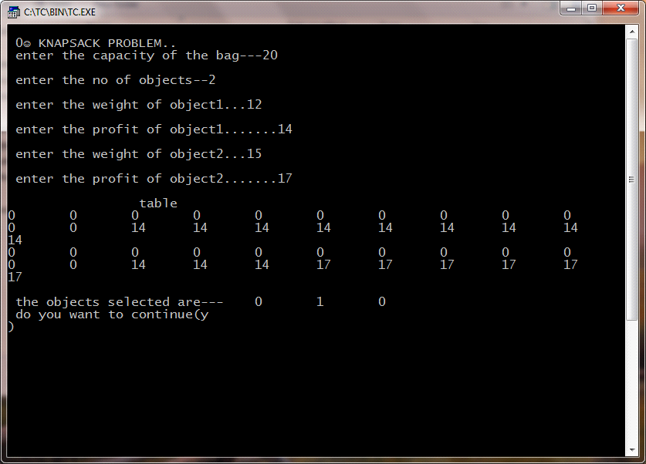

NAME: AKSHAYA S ; REG.NO: 22TD0005 ; YEAR/SEM/SEC: Y2/S4/B

ALL PAIRS SHORTEST PATH

#include<iostream>
using namespace std;
int a[20][20],cost[20][20],i,j,n,k;
class path
{
public:
void get();
void allpair (int a[20][20],int n);
void put();
};
void path::get()
{
cout<<"\n\t ALL PAIR SHORTEST PATH\n";
cout<<"\n Enter the no of vertex";
cin>>n;
cout<<"\nEnter the cost";
for(i=1;i<=n;i++)
{
for(j=1;j<=n;j++)
{
if(i==j)
{
cost[i][j]=0;
a[i][j]=cost[i][j];
}
else
{
cout<<"\n cost["<<i<<"]["<<j<<"]=";
cin>>cost[i][j];
a[i][j]=cost[i][j];

}
}
cout<<"\n";

}
}
void path::allpair (int a[20][20],int n)
{
for(k=1;k<=n;k++)
{
for(i=1;i<=n;i++)
{
for(j=1;j<=n;j++)
{
if((a[i][k]+a[k][j])<a[i][j])
{
a[i][j]=a[i][k]+a[k][j];
}
}
}
}
}
void path::put()
{

cout<<"\n OUTPUT";
cout<<"\n all pair shortest path \n";
for(i=1;i<=n;i++)
{
for(j=1;j<=n;j++)
{
cout<<a[i][j];
cout<<"\t";

}
cout<<"\n";
}
}
int main()
{
path p;
p.get();
p.allpair (a,n);
p.put();
}

OUTPUT:

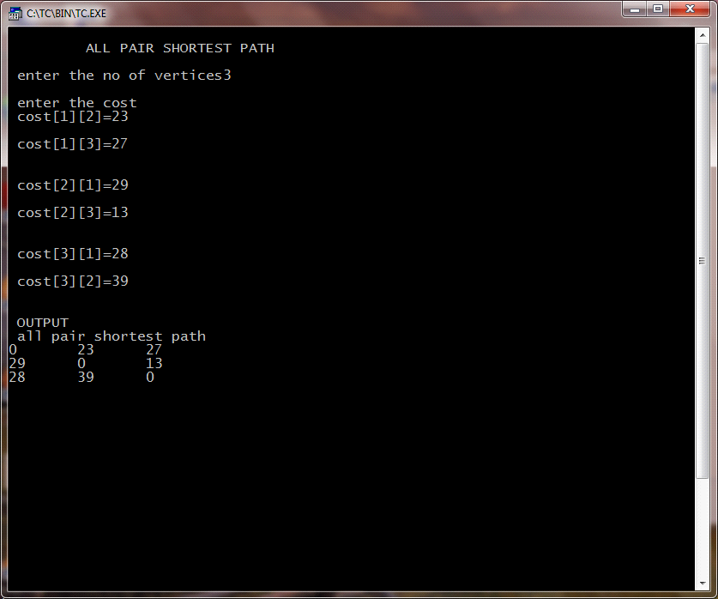

NAME: AKSHAYA S ; REG.NO: 22TD0005 ; YEAR/SEM/SEC: Y2/S4/B

TRAVELLING SALESMAN USING DYNAMIC PROGRAMMING

#include<iostream>
using namespace std;
class sales
{
int cost[20][20];
int i,a[20],min,result[20],j,x,n;
public:
void input();
int dts(int v,int t[10],int x,int path[20]);
void display();

};
void sales::input()
{
cout<<"\n travelling salesman problem \n";
cout<<"\nEnter the values of n:";
cin>>n;
cout<<"\nfrom to distance\n";
do
{
cin>>i;
i--;
cin>>j;
j--;
if((i==-1)&&(j==-1))
break;
cin>>cost[i][j];
}
while(1);
for(i=1;i<=n;i++)
cost[i][j]=0;
for(i=0;i<n-1;i++)
a[i]=i+1;
min=dts(0,&a[0],n-1,&result[0]);
}
int sales::dts(int v,int t[10],int x, int path[20])
{
int a[20],j,i,k,min=999,temp[10],y;
for(i=0;i<=n;i++)
a[i]=0;
if(x==0)
{
*path =v;
return (cost[v][0]);
}
else if(x==1)
{
path[0]=t[0];
path[1]=0;
return(cost[v][t[0]]+cost[t[0]][0]);
}
else
{
for(i=0;i<x;i++)
{
k=0;
for(j=0;j<x;j++)
{
if (t[j]!=t[i])
{
a[k]=t[j];
k++;
}
}
y=(cost[v][t[i]]+dts(t[i],a,x-1,temp));
if(min>y)
{
path[0]=t[i];
k=1;
min=y;
for(j=0;j<x;j++)
{
path[k]=temp[j];
k++;
}
}
}
}
return(min);
}
void sales::display()
{
cout<<"\nthe resultant path is:"<<endl;
cout<<"l";
for(i=0;i<n;i++)
{
cout<<"---------";
cout<<result[i]+1;

}
cout<<"\n the total distance :"<<min;
}
int
main()
{
sales t;
t.input();
t.display();

}

OUTPUT:

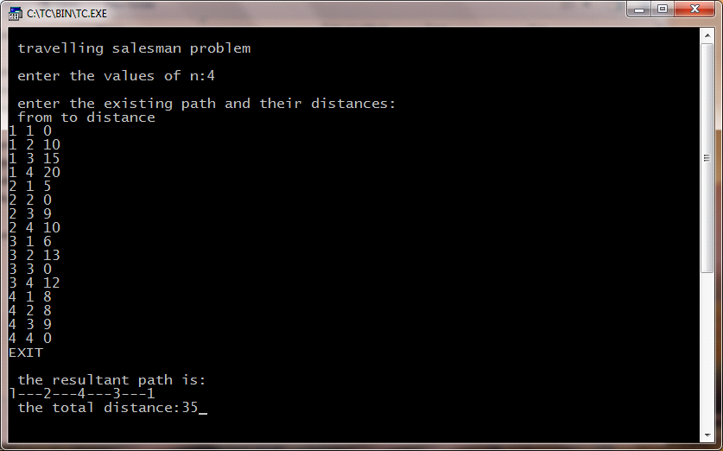

NAME: AKSHAYA S ; REG.NO: 22TD0005 ; YEAR/SEM/SEC: Y2/S4/B

DEPTH FIRST SEARCH

#include<iostream>
using namespace std;
int n,mark[20],adj[50][50],i,j;
class dfs
{
public:
void getdata(void);
void src(int n);
};
void dfs::src(int v)
{
int w;
mark[v]=1;
cout<<"\nVisited node:"<<v;
for(w=1;w<=n;w++)
if((mark[w]==0)&&(adj[v][w]==1))src(w);
}
void dfs::getdata(void)
{
cout<<"\nEnter the number of vertices:";
cin>>n;
cout<<"\nEnter if there is direct path else enter 0:\n";
for(i=1;i<=n;i++)
{
for(j=i+1;j<=n;j++)
{
cout<<"\nvertex"<<i<<"to"<<j<<":";
cin>>adj[i][j];
}
}
}
int main()
{
dfs d;
d.getdata();
for(i=1;i<=n;i++)
mark[i]=0;
d.src(1);
}

OUTPUT:

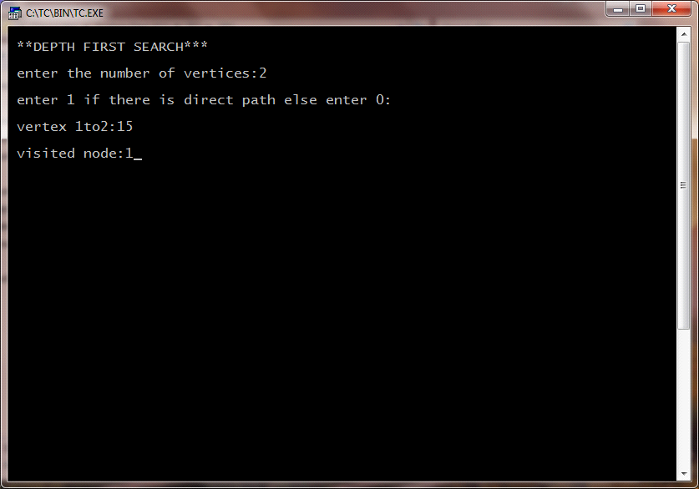

NAME: AKSHAYA S ; REG.NO: 22TD0005 ; YEAR/SEM/SEC: Y2/S4/B

BREADTH FIRST SEARCH

#include<iostream>
using namespace std;
int i,j,n,a[50],mark[20],adj[50][50],top=0;
int del();
void add(int temp)
{
a[++top]=temp;
}
int del()
{
int temp;
temp=a[1];
for(i=1;i<top;i++)
a[i]=a[i+1];
top--;
return(temp);

}
void bfs(int v)
{
int w,u;
mark[v]=1;
add(v);
while(top!=0)
{
u=del();
cout<<"\n\nVISIT NODE="<<u;
for(w=1;w<n;w++)
if((mark[w]==0)&&(adj[v][w]==1))
{
mark[w]=1;
add(w);
}
}
}
int main()
{
cout<<"\n\nBREATH FIRST SEARCH:";
cout<<"\nEnter the no of nodes:";
cin>>n;
cout<<"\nEnter 1if there is an edge between nodes else type 0";
for(i=1;i<=n;i++)
{
for(j=i+1;j<=n;j++)
{
cout<<"\n\n node"<<i<<"to node"<<j<<"=";
cin>>adj[i][j];
}
}
for(i=1;i<=n;i++)
mark[i]=0;
for(i=1;i<=n;i++)
if(mark[i]==0)
bfs(i);

}

OUTPUT:

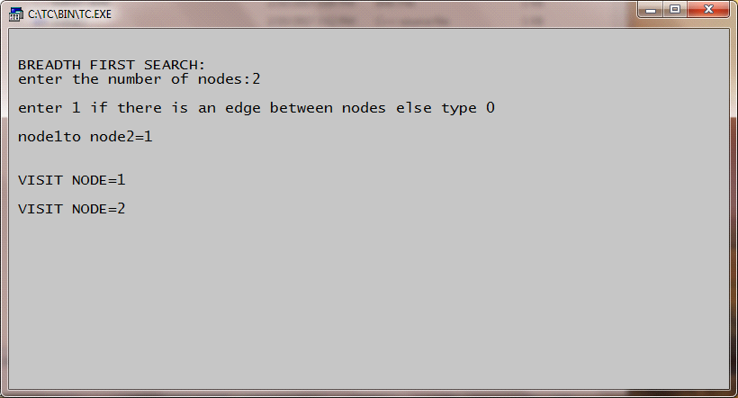

NAME: AKSHAYA S ; REG.NO: 22TD0005 ; YEAR/SEM/SEC: Y2/S4/B

N QUEENS

#include<iostream>
#include<stdlib.h>
using namespace std;
void addqueen();
int col[8],upfree[15],dnfree[15],coln[15];

void addqueen()
{
int i,c,r;
static int comb,row=-1;
row++;
for(i=0;i<=7;i++)
{
if(col[i]&&upfree[i+row]&&dnfree[row-i+7])
{
coln[row]=i;
col[i]=0;
upfree[i+row]=0;
dnfree[row-1+7]=0;
if(row>=7)
{
comb++;
cout<<"\n\n\t 8 queens problem";
cout<<"\n combination no:"<<comb;
for(r=0;r<=7;r++)
{
cout<<endl;
for(c=0;c<=7;c++)
{
if(c=coln[r])
{
cout<<"\tx";

}
else
{
cout<<"\t";
}
}
}
}
else
addqueen();
col[coln[row]]=1;
upfree[row+coln[row]]=1;
dnfree[row-coln[row]+7]=1;
}
}
row--;
}
int main()
{
int i;
for(i=0;i<=7;i++)
col[i]=1;
for(i=0;i<=14;i++)
upfree[i]=dnfree[i]=1;
addqueen();
}

OUTPUT:

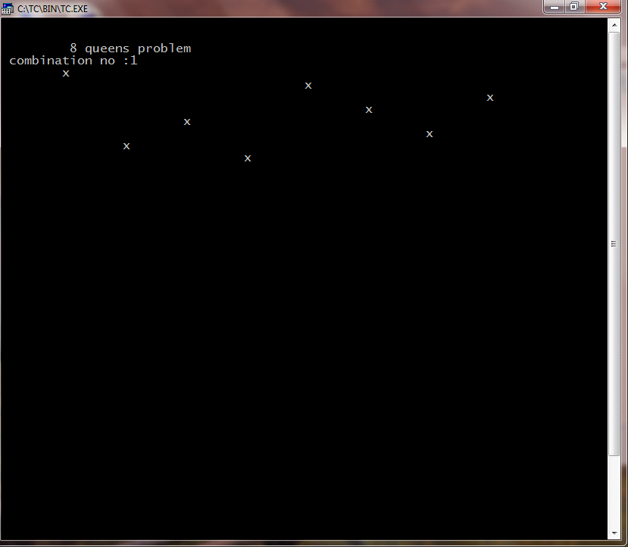

NAME: AKSHAYA S ; REG.NO: 22TD0005 ; YEAR/SEM/SEC: Y2/S4/B
SUM OF SUBSET

#include<iostream.h>
#include<conio.h>
int m,n,w[10],x[10];
void sum_subset(int s,int k,int r)
{
int i;
x[k]=1;
if(s+w[k]==m)
{
for(i=1;i<=n;i++)
{
cout<<"x["<<i<<"]:"<<x[i]<<"\t";
}
cout<<"\n";
}
else
{
if((s+w[k]+w[k+1])<=m)
{
sum_subset(s+w[k],k+1,r-w[k]);
}
}
if(((s+r-w[k])>=m)&&((s+w[k+1])<=m))
{
x[k]=0;
sum_subset(s,k+1,r-w[k]);
}
}
void main()
{
cout<<"enter the no of values:";
cin>>n;
cout<<"enter the sum:";
cin>>m;
cout<<"enter the values:";
int i;
for(i=1;i<=n;i++)
{
cin>>w[i];
}
int r;

r=0;
for(i=1;i<=n;i++)
{
r+=w[i];
}
sum_subset(0,1,r);
getch();
}

OUTPUT:

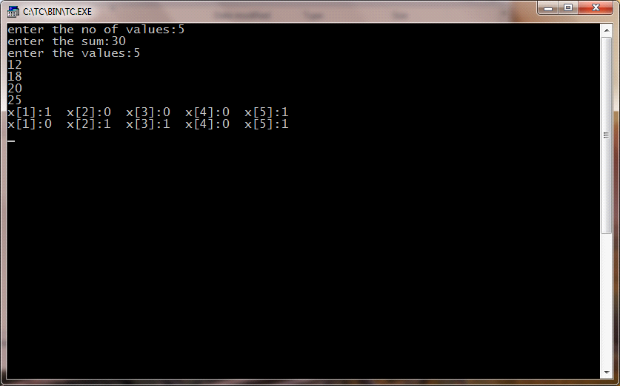

NAME: AKSHAYA S ; REG.NO: 22TD0005 ; YEAR/SEM/SEC: Y2/S4/B

0/1 KNAPSACK PROBLEM USING BRANCH AND BOUND TECHNIQUE

#include<iostream.h>
#include<conio.h>
#include<stdlib.h>
#include<stdio.h>
int entries;
float ratio[20];
float *knapsack(int weight[20],int,int);
void sortpw(int pro[20],int weight[],int,int);
void main()
{
int pro[20];
int weight[20];
int maxwt=0,i,entries=0,count=0,minmax;
clrscr();
cout<<"\n enter no of entries:";
cin>>entries;
for(i=0;i<entries;i++)
{
cout<<"\n entry"<<i+1<<".";
cout<<"\n enter profit:";
cin>>pro[i];
cout<<"\n enter weight[i]";
cin>>weight[i];
ratio[i]=(float)pro[i]/weight[i];
count++;
}
cout<<"maximum weight allowed:\n";
cin>>maxwt;
cout<<"\n maximum profit-->1 or 0:";
cin>>minmax;
float*wrat=new float[count];
sortpw(pro,weight,count,minmax);
wrat=knapsack(weight,maxwt,count);
cout<<"\nprofit\tweight\tratio\n";
for(i=0;i<count;i++)
cout<<pro[i]<<"\t"<<weight[i]<<"\t"<<wrat[i]<<"\n";
cout<<endl;
int totpro=0;
for(i=0;i<count;i++)
totpro+=pro[i]*wrat[i];
cout<<"\n total profit:"<<totpro;
getch();
}
void sortpw(int pro[],int weight[],int count,int minmax)
{
int i,j;
for(i=0;i<count;i++)
{
for(j=i+1;j<count;j++)
{
if((ratio[i]<ratio[j])&&minmax)
{
float t;
int tl;
t=ratio[i];
ratio[i]=ratio[j];
ratio[j]=t;
tl=pro[i];
pro[i]=pro[j];
pro[j]=tl;
tl=weight[i];
weight[i]=weight[j];
weight[j]=tl;
}
else if((ratio[i]>ratio[j])&&!minmax)
{
float t=0;
int tl;
t=ratio[i];
ratio[i]=ratio[j];
ratio[j]=t;
tl=pro[i];
pro[i]=pro[j];
pro[j]=tl;
tl=weight[i];
weight[i]=weight[j];
weight[j]=tl;
}
}
}
}

float *knapsack(int weight[20],int maxwt,int count)
{
int filledwt=0;
float *wratio=new float[count];
int i;
for(i=0;i<count;i++)
wratio[i]=0.0;
i=0;
while((filledwt<maxwt)&&(i<count))
{
if((filledwt+weight[i])<=maxwt)
{
wratio[i]=1.0;
filledwt+=weight[i];
}
i++;
if(i==count)
break;
}
return wratio;
}

OUTPUT:

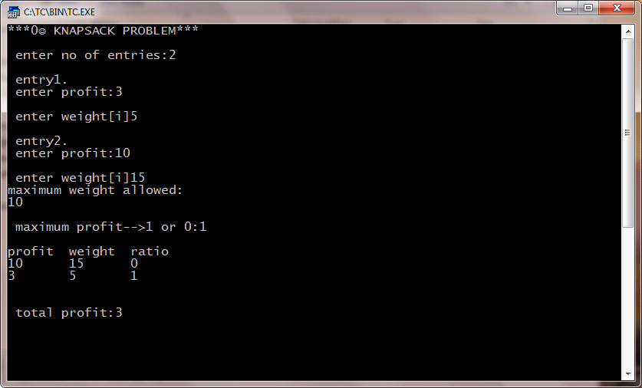

NAME: AKSHAYA S ; REG.NO: 22TD0005 ; YEAR/SEM/SEC: Y2/S4/B

TRAVELLING SALESMAN PROBLEM
#include<iostream.h>
Using name space std;
int main()
{
int i,j,k,n,min,g[20][20],c[20][20],s,s1[20][1],s2,lb;
cout<<"\n TRAVELLING SALESMAN PROBLEM";
cout<<"\n input number of cities:";
cin>>n;
for(i=1;i<=n;i++)
{
for(j=1;j<=n;j++)
{
c[i][j]=0;
}
}
for(i=1;i<=n;i++)
{
for(j=1;j<=n;j++)
{
if(i==j)
continue;
else
{
cout<<"input"<<i<<"to"<<j<<"cost:";
cin>>c[i][j];
}
}
}
for(i=2;i<=n;i++)
{
g[i][0]=c[i][1];
}
for(i=2;i<=n;i++)
{
for(j=2;j<=n;j++)
{
if(i!=j)
g[i][j]=c[i][j]+g[j][0];
}
}

for(i=2;i<=n;i++)
{
for(j=2;j<=n;j++)
{
if(i!=j)
break;
}
}
for(k=2;k<=n;k++)
{
if(i!=k&&j!=k)
{
if((c[i][j]+g[i][k]<c[i][k]+g[k][j]))
{
g[i][j]=c[i][j]+g[j][k];
s1[i][j]=j;
}
else
{
g[i][1]=c[i][k]+g[k][j];
s1[i][1]=k;
}
}
}
min=c[1][2]+g[2][1];
s=2;
for(i=3;i<n;i++)
{
if((c[i][i]+g[i][i])<min)
{
min=c[1][i]+g[i][1];
s=i;
}
}
int y=g[i][1]+g[i][j]+g[i][i];
lb=y/2;
cout<<"edge matrix";
for(i=1;i<=n;i++)
{
cout<<"\n";
for(j=1;j<=n;j++)
{
cout<<"\t"<<c[i][j];
}

}
cout<<"\n min"<<min;

cout<<"\n\b"<<lb;
for(i=2;i<=n;i++)
{
if(s!=i&&s1[s][1]!=i)
{
s2=i;
}
}
cout<<"\n"<<1<<"---->"<<s<<"----->"<<s1[s][1]<<"---->"<<s2<<"---->"<<1<<"\n";
return 0;
}

OUTPUT:

